Bruschetta Chicken Pasta Salad

Prep Time 10 mins Cook Time 15 mins
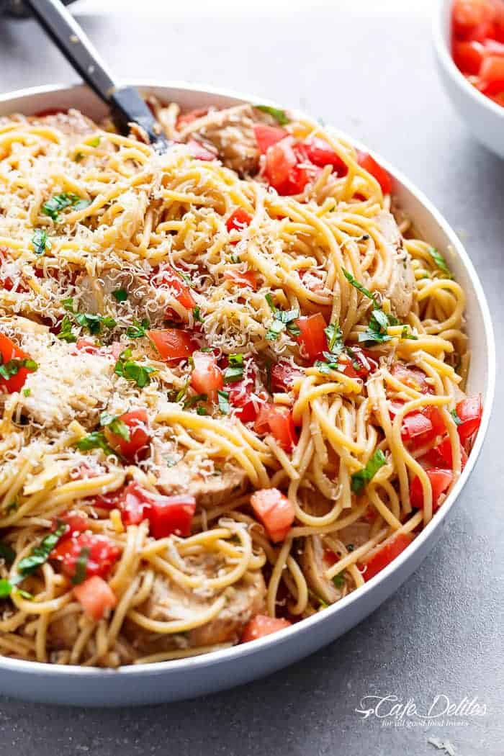
6 Servings

Ingredients
1 lb. thin spaghetti pasta, (dry weight)
1 lb. boneless skinless chicken breasts, (2 large breasts)
1 teaspoon dried basil
1 teaspoon dried oregano
1/2 teaspoon garlic powder
Salt and pepper, to taste
1/4 cup olive oil
2 tablespoons minced garlic
2 tablespoons red onion, finely chopped (about 1/3 of a red onion)
2 tablespoons balsamic vinegar, (adjust to your tastes)
8 Roma tomatoes, diced
1/2 cup grated parmesan cheese, plus more to serve
2 tablespoons finely chopped fresh basil or parsley
Salt and pepper, to taste
Balsamic glaze to serve (optional)

Directions
- Cook pasta, drain and rinse in cold water. Transfer to a large bowl; set aside.

- Season chicken with the herbs, garlic powder, salt and pepper. Heat 1 tablespoon of oil in skillet and sear chicken breasts over medium-high heat until browned on both sides and cooked through (about 6 minutes each side). Remove from pan; set aside and allow to rest.

- Add the remaining olive oil to the same skillet. When hot, sauté the garlic and red onion until garlic is fragrant (about 1 minute). Turn off heat.

- Add in the tomatoes, toss them lightly in the heat to warm them through and combine all of the flavors. Add the tomato mixture onto the pasta.

- Mix in the vinegar, parmesan cheese and basil (or parsley). Season with salt and pepper to your taste. Slice the chicken; add to pasta. Toss the pasta with all of the ingredients until well combined.

- Top with 2 tablespoons of extra parmesan cheese (optional) and serve immediately with balsamic glaze OR refrigerate up to an hour before serving.

Notes
Salad can be served warm (heated through in the same pan as the olive oil tomato mixture) OR cold as described in the recipe.

